**Student Name: Juan J Barillas Ruiz**

**2016 Fall - CS81 (1755)**

**Problem #1: Create GitHub Account**

Link: <https://github.com/jbarill/unit7->

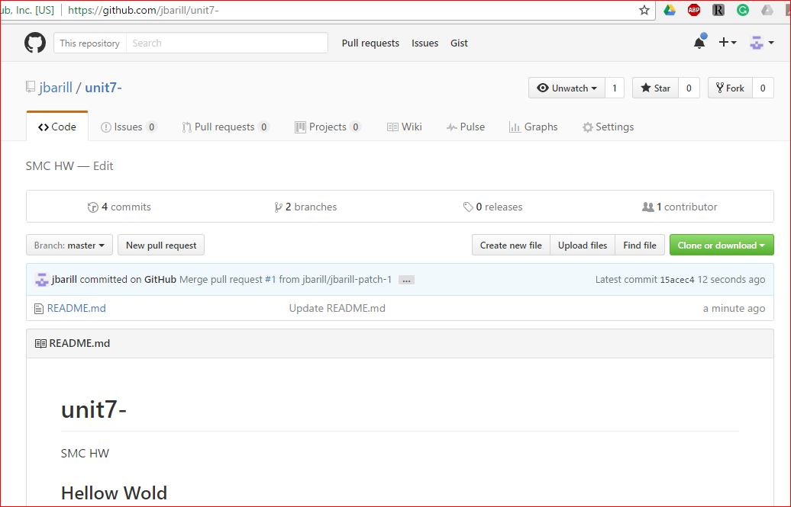

**Problem #2: Breakpoints**

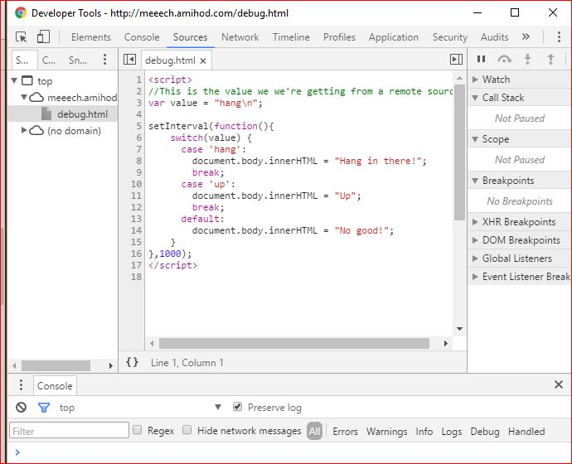

**#2**

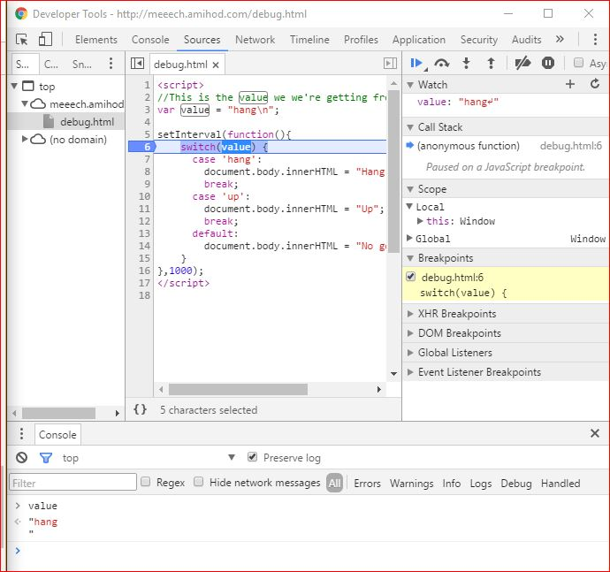

**#3**

